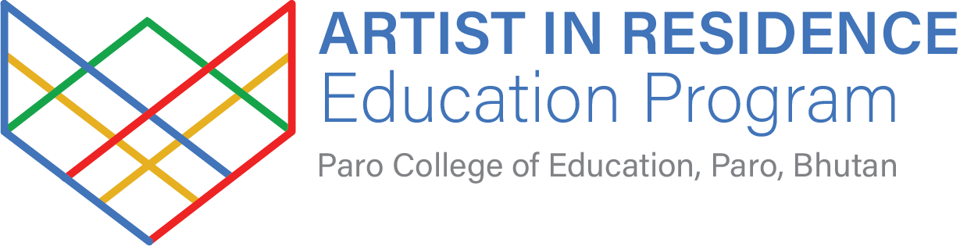

Pema’s shop

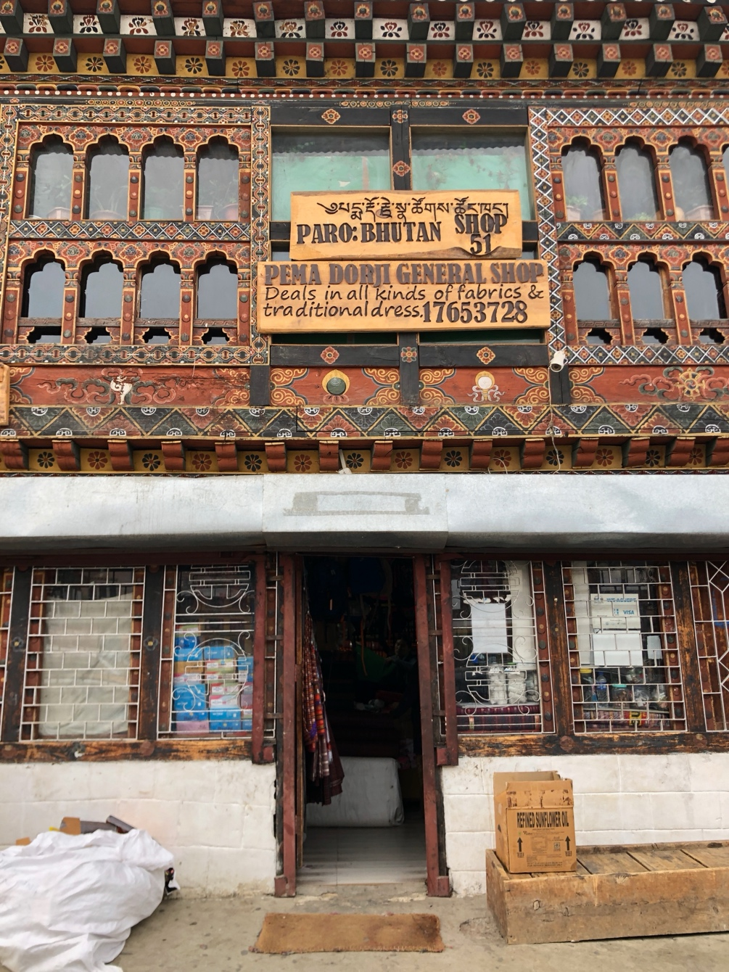

In the middle of Main Street, Paro, is Pema’s fabric shop. It is a cultural gem that keeps alive Bhutan's traditional weaving. I have spent many hours browsing through rooms piled high with fabrics. I bought all my kira, thago, and wanshu there and have been awarded the ultimate compliment of being invited to sit on a stool at the counter, drink masala tea, and chat with Pema like a local. Pema sources much of her stock from the villages throughout Bhutan. She employs members of her family to attend to customers in an always-packed shop. Pema has a huge collection of naturally dyed, silk embroidery threads that I can’t resist.

